MCP server up and running in the streamable http in 8000 port.
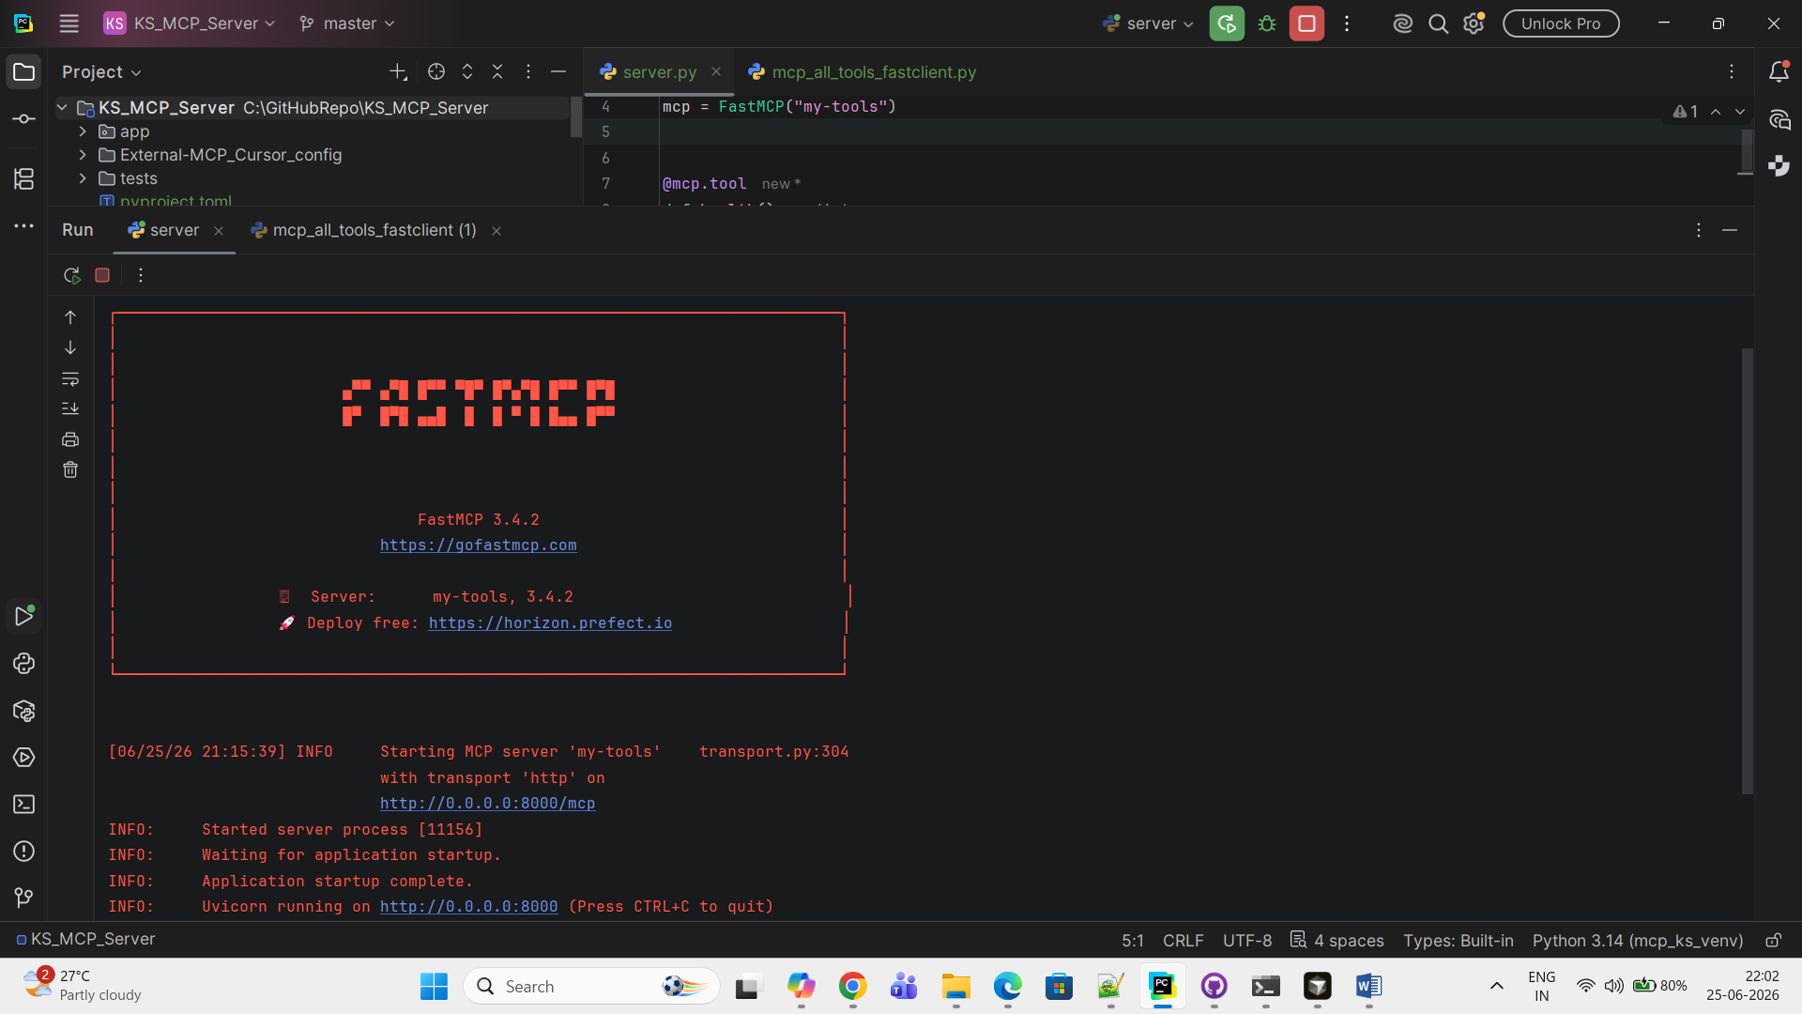

External MCP configuration in Cursor:-
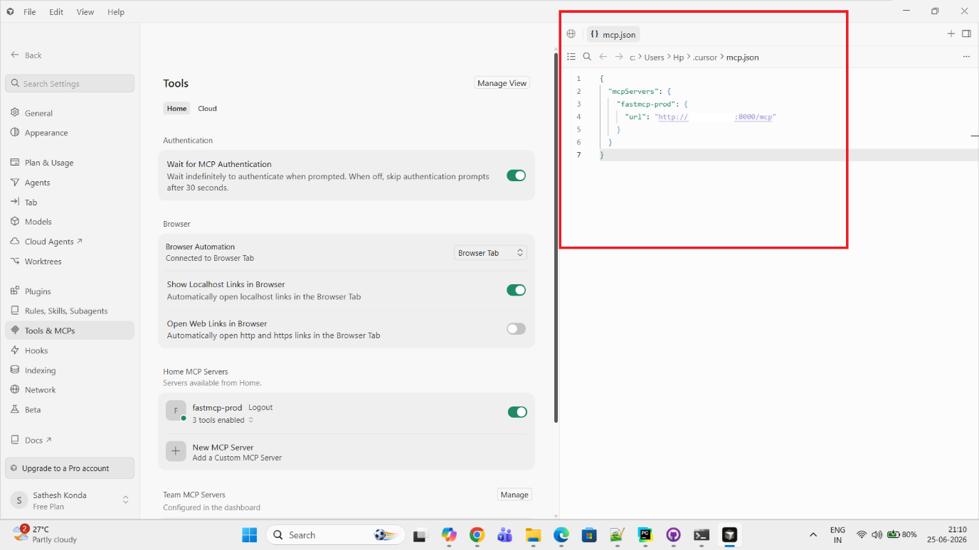

Re-Opened the Cursor and querying.
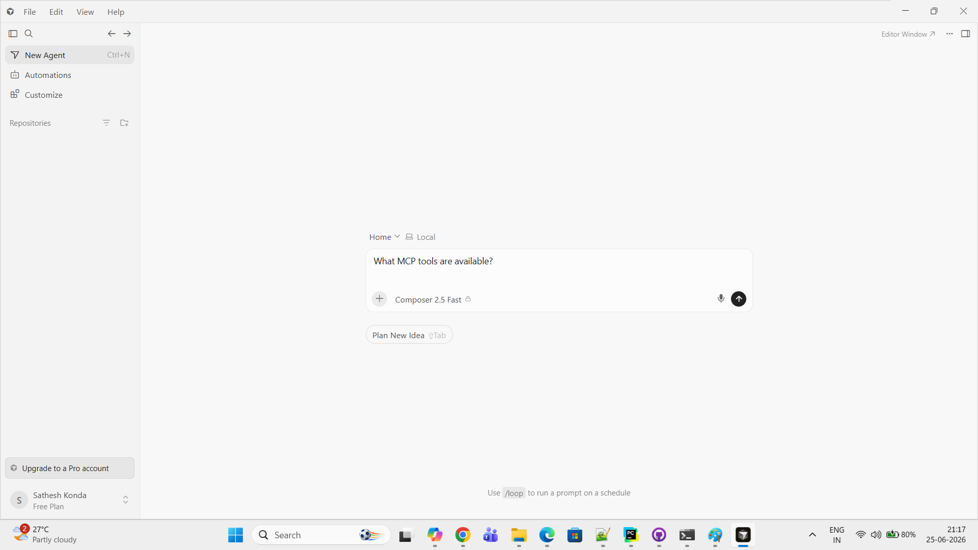
Output: Shown the MCP server and it’s tools list.
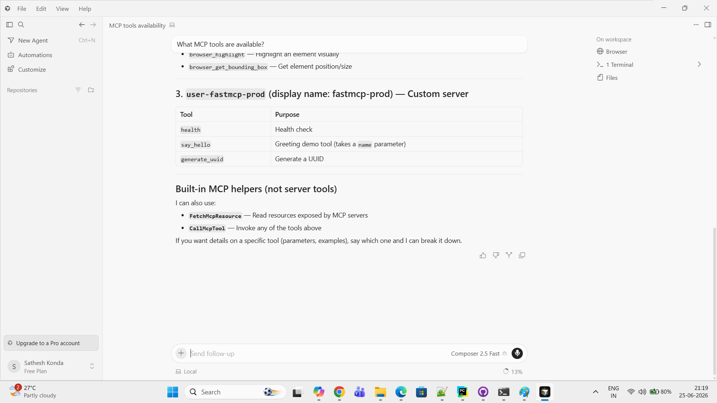

Query-2: Say hello to Pavan Kumar then cursor called our external tool ‘say_hello’ of ‘fastmcp-prod’ MCP server.
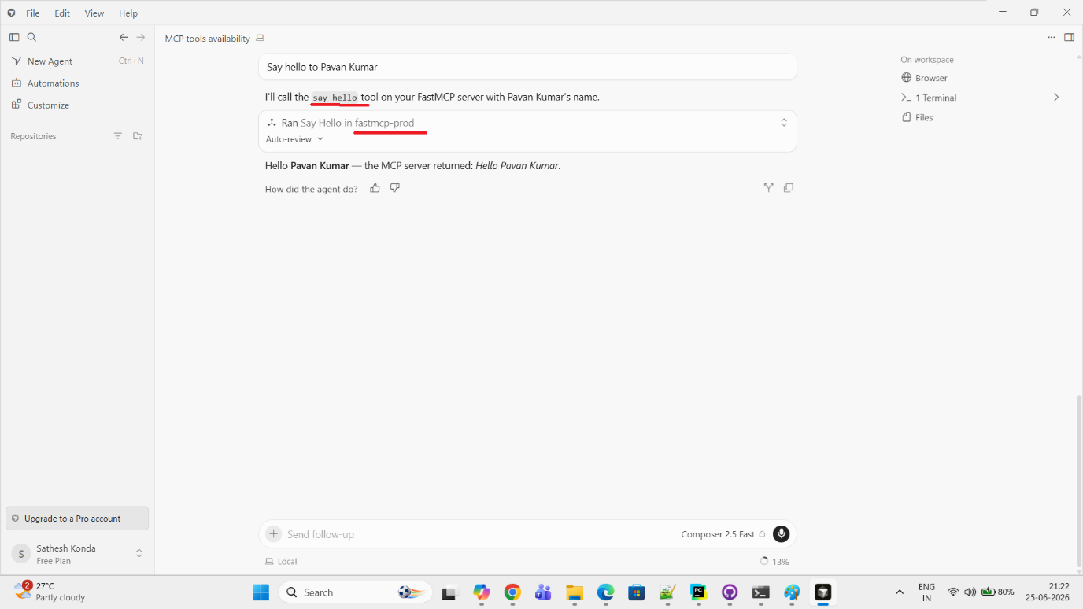
Query-3: Generate UUID then cursor called our external tool ‘generate_uuid’ of fastmcp-prod’ MCP server.
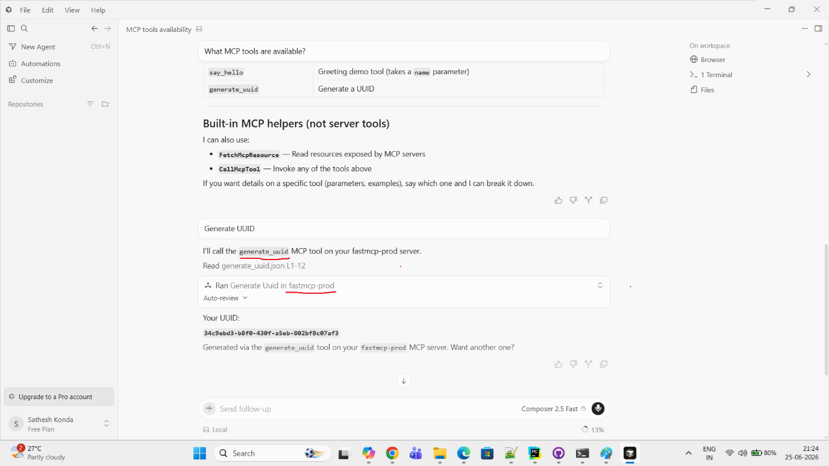

Final Logs captured in MCP server side.
